***LUNG DISEASE AND TREATMENTS 17/03/2021***

***HUMAN BIOLOGY YEAR 11 EXTENDED RESPONSE - MA PUNITHA NAGENDIRAN***

***CYSTIC FIBROSIS***

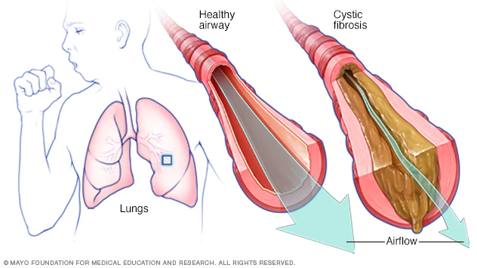

*Cystic Fibrosis (CF) is an inherited lung disorder that deteriorates an individual's lungs, digestive system and multiple other organs. In order to be diagnosed with CF, the defective gene must be found in both parents, but if only one parent is the carrier to the defective gene, then they won't show any symptoms of CF however, they are still able to pass it down to their child. Cystic Fibrosis is a disease that requires daily care and is heavily progressive. Although individuals with cystic fibrosis are able to live a normal life (attend school and work), individuals who have severe forms of this disease are left in the ER. The symptoms of CF however depend on the severity of the individual's diagnosis. CF is caused due to a defective or change in a gene, CFTR (cystic fibrosis transmembrane conductance regulator) which can be inherited through generations. The specific gene is in charge of the flow of salt and fluids in and out of an individual's cells. It affects the cells that produce mucus, sweat and digestive juices. In a person without CF, the fluids that they produce are usually thin and slippery, as well as the fluids acting as a lubricant in their system but due to the defective gene that the person with CF has, it causes the fluid to become thick and sticky. Plugging up multiple tubes, ducts and passageways that are most commonly affecting the lungs,pancreas, intestines and liver.* 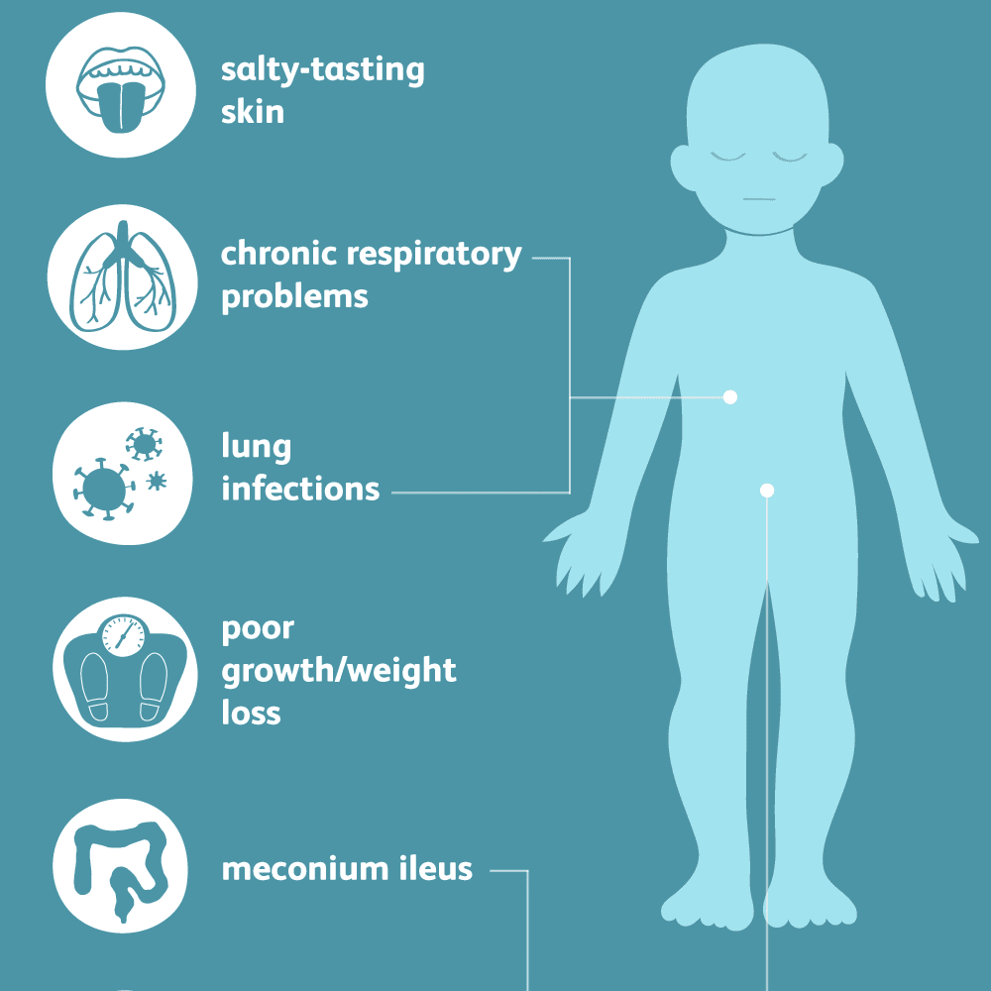

*Symptoms and diagnosis of cystic fibrosis vary between every individual who has it. Most commonly, people are born with CF and are able to show traits immediately of the disease at birth. However individuals may experience symptoms later on in their childhood or adulthood. The severity of the symptoms may also vary between individuals such as some children showing signs of mild digestive and lung problems while on the other hand, another child may have severe life-threatening breathing complications as well as problems with absorption of foods. There are various symptoms to CF, however the most common symptoms are salty tasting skin which is easily noticeable by parents when they kiss their child, continuous cough, wheezing or bouts of pneumonia or sinusitis, difficulty breathing that progresses quickly, large appetite but poor weight gain and large, odourful, greasy bowel movements. As time passes by, an individual’s cystic fibrosis can worsen and may show symptoms such as chronic productive coughing, recurring lung infections, obstructive lung disease (emphysema), chronic nasal congestion and sinus infections, pancreatitis (painful inflammation of the pancreas due to the blockage by mucus and other fluids), various liver diseases (Steatosis, Neonatal cholestasis, choletlithiasis and Multilobular cirrhosis), diabetes and gallstones (hardened deposits of bile that form in the gallbladder). It’s best to consult with a doctor if you’re planning to get pregnant, are pregnant or if both you and your partner have a past family history of cystic fibrosis. Although it is still best to consult with a doctor if your child is having problems with putting on or maintaining their weight. Early diagnosis of CF and treatment is important to the improvement of an individuals quality of life and lengthening the expected lifespan of 40-50 years. A person can be diagnosed with Cystic Fibrosis by consistent clinical symptoms of CF in one or more of the organ system and if the individual has the defective gene.*

*Treatment*

*There’s no overall cure to cystic fibrosis however there are multiple treatments that are able to manage the symptoms, prevent or reduce the complications and make life easier for those who have cystic fibrosis. Regular checkups to monitor an individual’s condition are needed and a care plan will be set up to suit the individual’s needs. The most common problem an individual may experience are lung problems. The medicine that are usually prescribed in order to control CF are antibiotics, medicine in order to thin out mucus in the lungs, medicine to help reduce the mucus level in the lungs, bronchodilators to widen airways and steroid medicine to treat small growth inside the nose. People with cF must be up to date with all the routine vaccination and a flu jab once they’re old enough. Exercise is also highly recommended in order to clear mucus from lungs and improve physical strength and overall health. There’s airway clearance techniques where a physiotherapist can also teach techniques to keep the lungs and airways clear. Eating well is important for an individual with CF as mucus makes it difficult to digest food and absorb nutrients into the systems. However in serious cases of CF, the lungs may stop working and all other medical treatments, an individual may need an emergency lung transplant.*

*Preventions*

*Cystic Fibrosis can not be prevented but genetic testing can be performed for a couple who is wishing to get pregnant or already pregnant that may have CF or relatives that have CF. Although genetic testing that is able to determine a child’s risk of CF. This can be tested using a sample of blood or saliva from each parent. The tests are able to be performed during pregnancy to see the health of your child.*

***PNEUMONIA***

*Pneumonia is an infection of one or both lungs that is mainly caused by bacteria, viruses or fungi. The infection creates inflammation in the air sacs (alveoli) inside your lungs. The air sacs fill up with fluids or pus, to make breathing difficult. Pneumonia can be contagious due to the germs that cause it. Viral and bacterial pneumonia are both very contagious that easily spread from one person to another. Pneumonia is able to spread by the inhalation of airborne droplets from a sneeze or cough. You are able to spread both viral and bacterial pneumonia by coming into contact with surfaces or objects that are contaminated with the bacteria or viruses. Although you’re able to contract fungal pneumonia from the environment, it isn’t spreadable.*

*Symptoms of pneumonia range from mild to life-threatening such as coughing, fever, sweating or chills, shortness of breath that occur during normal activities or while resting, chest pains that worsen when you breathe or cough, fatigue, loss of appetite, nausea or vomiting and headaches. There are differences in the symptoms due to age and the general health of an individual such as children under the age of 5 may experience heavy breathing or wheezing, infants may show no symptoms however may experience vomiting, fatigue or have trouble ingesting food and liquids. However older people experience milder symptoms but may exhibit symptoms of confusion or lower body temperature. There are various types of pneumonia. Bacterial pneumonia is caused by streptococcus pneumonia. Viral pneumonia is mainly caused by respiratory viruses such as influenza and is one of the milder types of pneumonia. Fungal pneumonia is caused by fungi due to soil or bird droppings, but will affect more to those with weakened immune systems.* 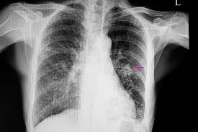

*Treatment*

*Treatment for pneumonia comes in many different forms; however to diagnose, your doctor will ask you about your medical history and hold a physical exam. The physical exam includes listening to your lungs using a stethoscope to check for irregular bubbling or crackling noises that may suggest that you have pneumonia. If pneumonia is suspected, your doctor will recommend various tests such as a blood test in order to confirm the infection, chest x-ray to help your doctor diagnose pneumonia and to know the extent of your diagnosis, pulse oximetry to measure the oxygen level in your blood and a sputum test. Your doctor may suggest taking an extra test such as a CT scan and a Pleural fluid culture. Specific treatments for pneumonia may differ depending on the type and severity, your age and overall health. Antibiotics may be prescribed to treat bacterial pneumonia. Cough medicine may be used as a treatment to calm the coughing. While fever reducer/pain relievers may be used as well. However hospitalisation may be needed to those who are older than 65 years old, experience confusion, kidney function is declining, systolic blood pressure is below 90 and diastolic being 60 or below, breathing needs assistance, body temperature is below normal and if the individual’s heart rate decreases below 50 or increases above 100.*

*Prevention*

*There are multiple ways to avoid getting pneumonia. Taking the flu vaccine once a year since people are able to develop Bacterial pneumonia after having a case of the flu. Taking the pneumococcal vaccine can prevent getting pneumonia caused by the pneumococcal bacteria. By practicing good hygiene, you wont get sick as often. Avoiding smoking as it damages your lungs and weakens them. Avoiding sick people by wearing a mask when out in public and practicing a healthy lifestyle.*